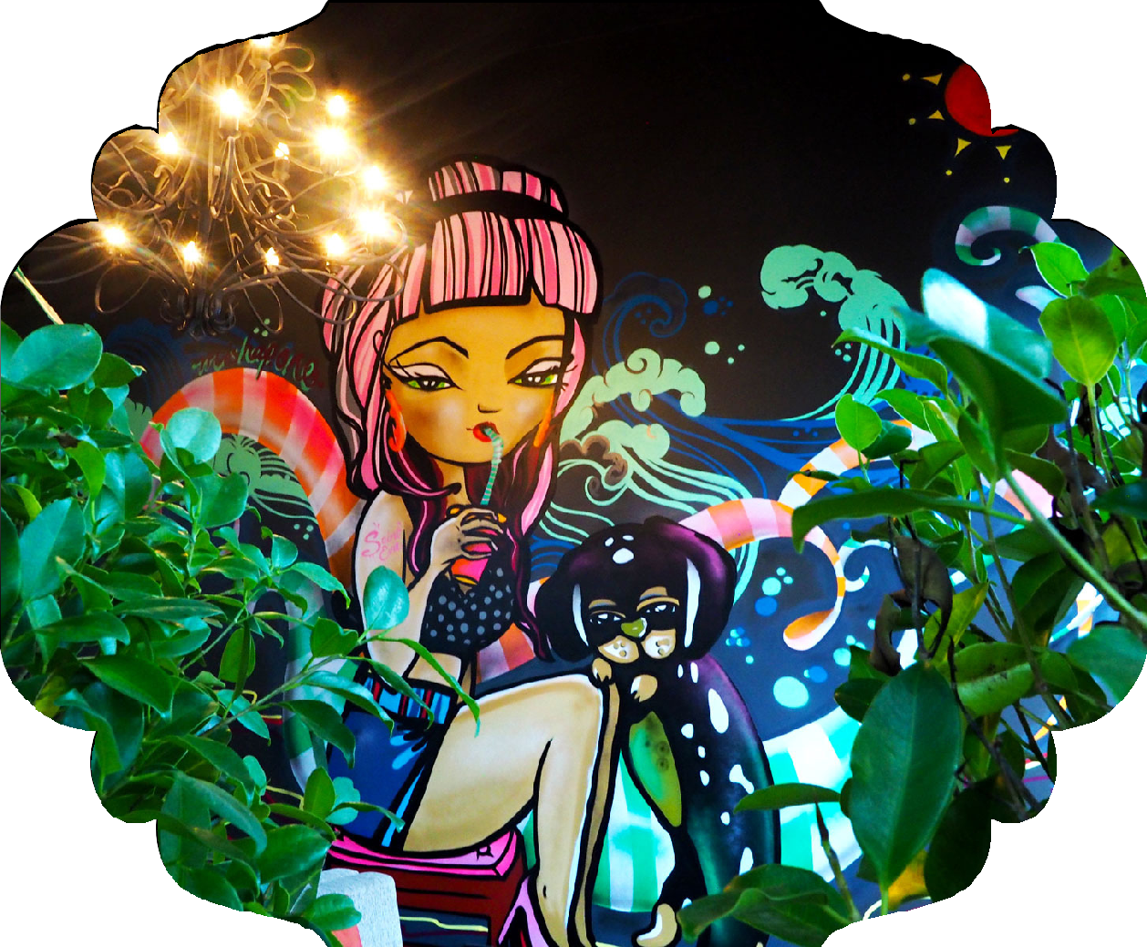

Signature Cocktails

The Saint $18 Finlandia Vodka, fresh lime & ginger w pink grapefruit juice
Scarlet Lavender $17 Finlandia Vodka, fresh lime & lavender
Honey Basil $18 Bacardi white Rum, fresh lime & basil
Eye Candy $17 Aperol, fresh lime & sage
Evie’s Mule $18 Finlandia Vodka, fresh lime, ginger, cucumber, angostura bitters topped w ginger beer
Boulevard Cherry $20 Ezra Brooks Bourbon, Vermouth, Cherry Brandy, fresh orange & lemon w angostura bitters
Match Made In Heaven $19 Cognac, Paul Louis French Bubbles & angostura bitters
Beyond Negroni $18 Tanqueray Gin, Campari, red vermouth & angostura bitters

Wine by the glass
Bubbles
NV Endless Sparkling Blanc de Blancs Victoria, Australia $9
NV Paul Louis Brut Rose’ Cremant de Loire Loire Valley, France $13
NV Paul Louis Brut Blanc de Blancs Loire valley, France $11
Pink
2016 Olivers Taranga Chica Mencia Rose’ Mclaren Vale,Australia $11
White
2017 Endless Sauvignon Blanc King Valley, Australia $9
2016 Te Mata Cape Crest Sauvignon Blanc Hawkes bay, NZ $12
2016 Cake Wines Pinot Gris Adelaide Hills, Australia $9
2015 Fat Bastard Chardonnay California, US $9
2015 Endless Chardonnay Central Victoria, Australia $8
Wine by the glass
Red
2016 Endless Pinot Noir Yarra Valley, Australia $10
2015 Poliziano Chianti Tuscany, Italy $11
2014 Lavau Cotes du Rhone Rhone Valley, France $9
2016 Endless Shiraz Heathcote, Australia $11

Wine by the bottle
Bubbles
NV Endless Sparkling Blanc de Blancs Victoria, Australia $38
NV Bandini Prosecco Veneto, Italy $42
NV Paul Louis Brut Rose’ Cre’mant de Loire Loire Valley, France $60
NV Paul Louis Brut Blanc de Blancs Loire valley, France $55
NV Canard Duchene Brut Cuvee Champagne, France $92
NV Louis Roederer Brut Premier Champagne, France $110
Pink
2016 Olivers Taranga Chica Mencia Rose’ Mclaren Vale, Australia $48
2016 Rameau D’or Golden Bough Provence Rose’ Provence, France $50
White
2017 Endless Sauvignon Blanc King Valley, Australia $38
2016 Beau Mayne Sauvignon Blanc Bordeaux, France $40
2016 Alta Chapter 14 Sauvignon Blanc Adelaide Hills, Australia $42
2016 Te Mata Cape Crest Sauvignon Blanc Hawkes bay, New Zealand $56
2017 Endless Pinot Grigio King valley, Australia $38
2016 Cake Wines Pinot Gris Adelaide Hills, Australia $42
2016 Breganze Pinot Grigio Superiore Veneto, Italy $44
2016 Reichsgraf von Kesselstatt Riesling Trocken Mosel, Germany $46
2013 Alexander Laible Riesling Trocken Baden, Germany $58
2015 Cape Barren Funky Goose Gruner Veltliner Adelaide Hills, Australia $44
2016 Contesa Pecorino Abruzzo, Italy $48
2015 Endless Chardonnay Central Victoria, Australia $38
2015 Fat Bastard Chardonnay California, US $40
Wine by the bottle
Light Reds
2016 Endless Pinot Noir Yarra Valley, Australia $38
2015 Fat Bastard Pinot Noir IGP Pays D’oc, France $40
2016 Totara Pinot Noir Marlborough, New Zealand $46
Old World Varietals
2017 Fat Bastard Malbec Mendoza, Argentina $40
2014 Lavau Cotes du Rhone Rhone Valley, France $42
2014 Bodegas Patrocinio Zinio Tempranillo, Graciano Rioja, Spain $44
2015 Poliziano Chianti Tuscany, Italy $50
2014 Ramos Pinto Duas Quintas Douro, Portugal $52
2016 Trediberri Langhe Nebbiolo Piedmont, Italy $58

New World Reds
2016 Endless Shiraz Heathcote, Australia $38
2016 Cape Barren Native Goose Shiraz McLaren Vale, Australia $46
2009 Brothers In Arms Shiraz Langhorne Creek, Australia $62
2013 Brothers In Arms Cabernet Sauvignon Langhorne Creek, Australia $62

Beer
Local Craft
Mornington Peninsula Lager Mornington Pen, VIC $8
Two Birds “Taco” Ale Spotswood, VIC $10
Gage Road Brewing Little Dove Pale Ale Palmyra, WA $10
Mornington Peninsula Pale Ale Mornington Pen, VIC $9
Two Birds Sunset Ale Spotswood, VIC $10
4 Pines Summer Ale Brookvale, NSW $8
Hop Culture Session IPA Mornington Pen, VIC $8
Bad Shepard Tiny IPA Cheltenham, VIC $8
Mornington Peninsula Brown Ale Mornington Pen, VIC $8
4 Pines Stout - 1st Space Beer Brookvale, NSW $8

Imported
Peroni Italy $9
Corona Mexico $8
Asahi Japan $9
Pabst Blue Ribbon Lager Pint Los Angeles, US $9

Cider
Somersby Pear UK $8
Somersby Apple UK $8

Non Alcoholic
Juices $5
Apple, Orange, Pineapple, Tomato, Cranberry & Grapefruit
Capi Sparkling Mineral Water 1lt $8
Capi Sparkling Mineral Water 250ml $5
Capi Lemongrass & Ginger Sparkling Mineral Water 250ml $5
Capi Pink Grapefruit 250ml $5
Capi Lemonade 250ml $5
Capi Ginger Ale 250ml $5
Capi Tonic Water 250ml $5
Capi Native Tonic Water 250ml $5
Coke 330ml $5
Coke No Sugar 330ml $5
Diet Coke 330ml $5
San Pedro Coffee
Latte $4
Flat White $4
Cappuccino $4
Long Black $4
Short Black $4
Espresso $3
Macchiato $3
Tea
Green Tea $4
English Breakfast $4
Chamomile $4
De Tox $4

